Document Library Use the CS Team Site

You will want to download a copy of this document and add screenshots. You will then submit the completed document in the assignment.

The files needed are located in the Z:\CS140\Additional Datafiles\Document Library folder or on your workstation if you downloaded the files from canvas.

**This assignment will be done on your workstation**

1. Rename a document library
   1. Rename your team document library to SharePoint Documents
   2. Capture a screenshot

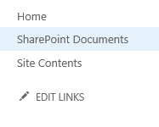

1. Create a new document from a document library
   1. From your SharePoint document library create a new document with the name of WhatisSharePoint
   2. Add your thoughts on what SharePoint is and save it in your document library
   3. Capture a Screenshot showing file created

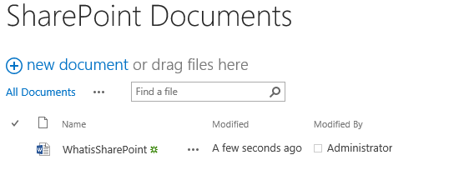

1. Upload a new document to a document library
   1. Browse to the location of the “Rename Document Library” file and upload to the SharePoint Documents document library
2. Upload Multiple Documents to a Document Library
   1. Upload three additional documents to the SharePoint Documents Library
   2. Capture a Screenshot of the contents of the SharePoint document Library

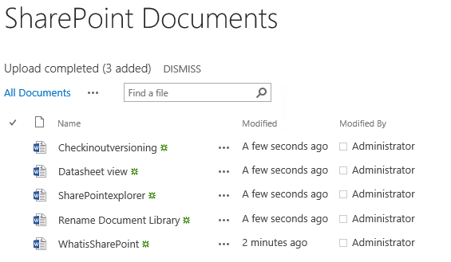

1. Quick Edit Mode
   1. Open the SharePoint Document Library in Quick Edit Mode and change the name of the “WhatisSharePoint” document to “What is SP”
   2. Capture a screenshot of the renamed document in quick edit

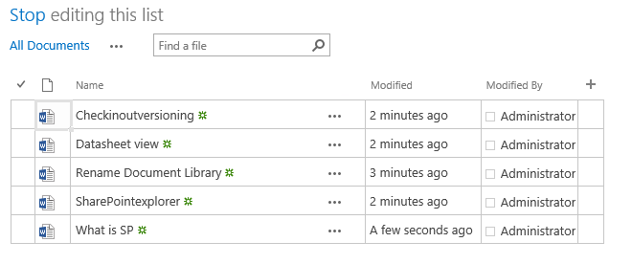

* 1. Return to the normal view

1. Check in / Check out and versioning
   1. Change versioning from No versioning to Create major versions
   2. Set your SharePoint Documents document library to require check/in, check/out
   3. Capture a screenshot showing the newly changed settings enabled

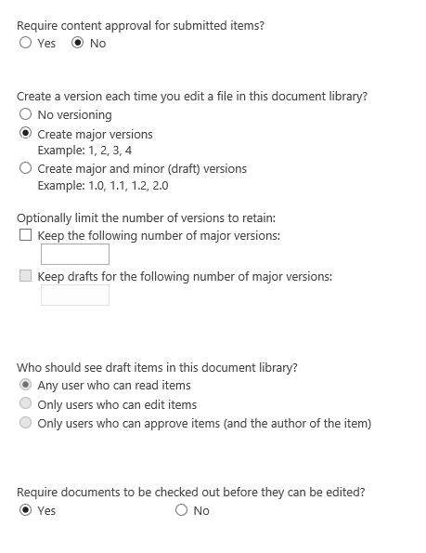

1. Check out a Document
   1. Checkout the “What is SP” document
   2. Make some changes in the document and then check it back in
   3. Enter comments when checking back in
   4. Capture a screenshot of the comments window

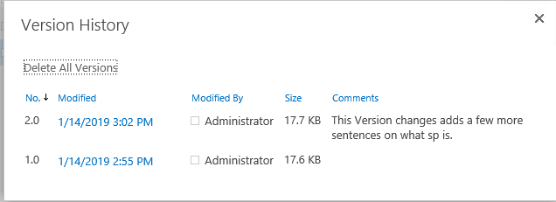

1. Check out a document and check it back in using word
   1. Check out the “What is SP” document by clicking the … and clicking on Edit
   2. Click Check Out
   3. Make some changes to the document
   4. Check in through word (click File, Check In)
   5. Add comments
   6. Capture a screenshot of entire window  
        
      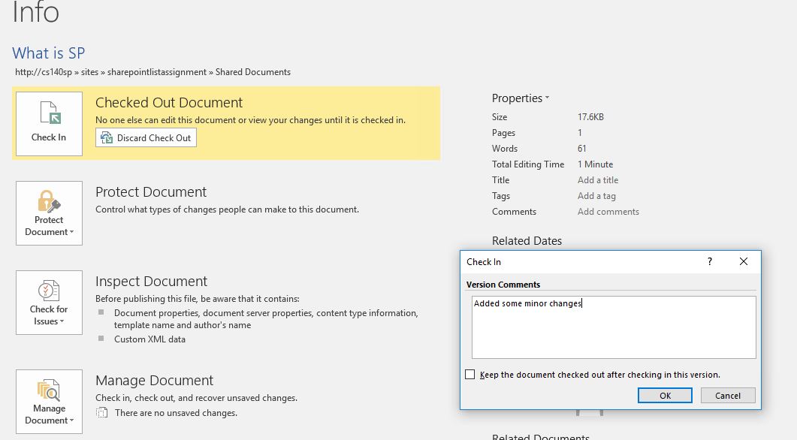
2. Review Document Version History for the “What is SP” document
   1. Click the three ellipsis next to the “What is SP” document and select the three ellipsis again
   2. Select Version History
   3. Select the down arrow next to the version you want to restore to expose the document’s contextual menu
   4. Capture a screenshot of the version history window

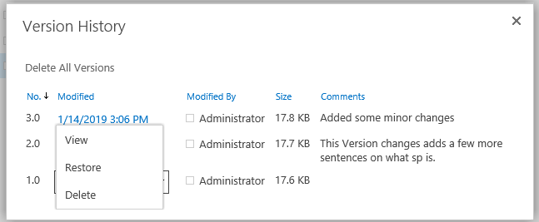

* 1. Click Restore

1. Windows Explorer View- Windows explorer view allows you to interact with your library with the usual Windows behaviors including dragging and dropping and creating folders. You must be using Internet Explorer to have access to this option **You will probably need to enter your credentials.
   1. Open the SharePoint Documents library in Windows Explorer view
   2. Create a folder named SharePoint Tips
   3. Copy your SharePoint documents into the new folder
   4. Capture a screenshot of the SharePoint tips folder in Windows Explorer view

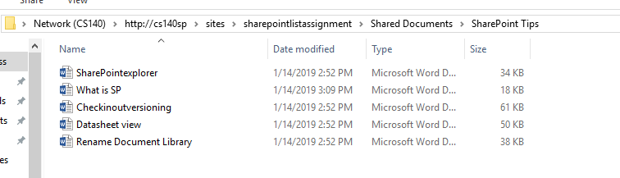

1. Create a Picture Library
   1. Be sure to select to Display on Quick launch
   2. Select Yes to the option to create a version of the file every time you edit in this library
2. Upload multiple pictures to the picture library
   1. Upload all the Company pictures at once to the picture library.
   2. Capture a screenshot of the picture library

